ProChef
Easily Create and Share High-Quality Recipes

Team Lead : Jason Januar – 300393865
CSIS 3375-001

1. Requirements Gathering

1a. Objectives / Goals
- Demographic
  - Identify user age range and household condition
    - GOAL: See if user demographic affects the other metrics identified in the survey
  - Identify users eating behaviors (prefer cooking or ordering food)
    - GOAL: Determine which user are chefs. Survey result of chefs will have higher weight since they’re our target demographic.
- Social Media Use
  - Identify if which social media does the user use (if any) and how often do they use it
    - GOAL: most popular social media will help be the inspiration for our app to determine the feel our app would want to have
  - Identify users social media behaviour (do they often post themselves or prefer just viewing other people’s content)
    - GOAL: determine how many users are likely to be interested in creating and sharing recipes, detemine how much emphasis our app would want to put to that aspect
  - Identify how influential social media is to the user’s cooking life (do they follow recipe-sharing accounts, do they share food photos or recipes themselves, etc)
    - GOAL: same as previous objective, but more directly specific to cooking stuff
- AI Opinions
  - Identify user opinion on AI usage
    - GOAL: app will need to have AI for some features but we want to determine if we should proudly showcase the AI usage or keep it low-key
- Use of Existing Competitors
  - Identify if users currently use a competing recipe app. If yes, which ones? If no, are you interested in using one in the future?
    - GOAL: We’ve done market research on the most popular apps but we’d like to have a better idea on which apps are our competition and try to make our app novel specifically against those apps.

1b. Choice of User Study and User Sample
We chose a survey since it’s simpler to do and we didn’t found a reason to use an interview model. Since our app target a rather general audience of “people who cook” we didn’t target a specific user sample and simply asked whoever was available between our friends and family members. Our survey does not have a dual perspective. Our app does have 2 possible perspectives which are content creators and content consumers but we decided that it was not necessary to have 2 different surveys for this.

1c. Survey Draft

ReciPro User Opinion Survey
We here in the ReciPro team are developing ReciPro, a recipe keeping app that would double as a social media app where users can create and share recipes with each other. Our app aims to transform the user’s social and culinary life by providing them tools to easily create and share high quality recipes with video and audio guides, it will be as if they’re teaching the viewers in person. As such, we would like to ask you some questions which would help us improve the user experience of the app and determine which aspects should we focus upon. Thank you in advance for taking your time to fill this survey.
How old are you? (choose one)
- < 20
- 21-30
- 31-40
- 41-50
- 51-60
- > 61
Do you live alone?
- Yes
- No
- Prefer not to say
Which of these options best describe your eating lifestyle? (choose one)
- I almost exclusively cook for myself, I rarely eat at restaurants or order food
- I prefer cooking for myself but sometimes still eat at restaurants or order food
- I both cook and eat out, I’m not more inclined to do one or the other
- I sometimes cook for myself but prefer eating out at restaurants or ordering food
- I almost never cook, I almost exclusively eat at restaurants or order food

Which of these social media sites do you use (choose any amount)
- X (formerly known as twitter)
- Instagram
- Facebook
- Snapchat
- TikTok
- YouTube
- Pinterest
- Reddit
- Other
- I do not use any social media

Which of these social media do you use most often? (choose one)
- (Show same options as previous question)

Which of these bests describe your behavior in social media? (choose one)
- I only post my own content and rarely look at other people’s content
- I prefer posting my own content more than looking at other people’s content
- I post my own content but also look at other people’s content
- I rarely post my own content, I prefer looking at other people’s content
- I only look at other people content and never post anything myself

Which of these best describe how social media affect your culinary life? (choose any amount)
- I often share recipes on social media
- I often look up recipes on social media
- I don’t do either of the above

Which of these bests describe your feelings of AI integration in applications (choose one)
- I enjoy using AI tools to increase productivity
- I’m indifferent to the presence of AI in applications
- I actively avoid apps that has AI in it
Do you use a recipe app? (choose one)
- yes
- no
(if no) Would you be interested in using a recipe app in the future? (choose one)
- Yes
- no
(if yes) Which one of these apps do you use? (choose any amount)
- (show all 12 apps that we perform market research on)
- Other

Which features in a recipe app that are most important to you (choose up to 3)
- Easily look up recipes
- Nutrition tracker
- Meal planner
- Online shopping app integration
- Pantry tracker
- Easily create your own recipes
- Easily import recipes from other sites
- Recipes with video tutorials
- Text-to-Speech recipe reader
- Leaving likes and comments to recipes
- Joining communities/groups of users with similar food interests
- Easily share recipes to external social media apps
- Other ____

Are there anything else you’d want to say to us? (optional open ended question)

1d. Data Visualization and Analysis
Sample Size: 10 People
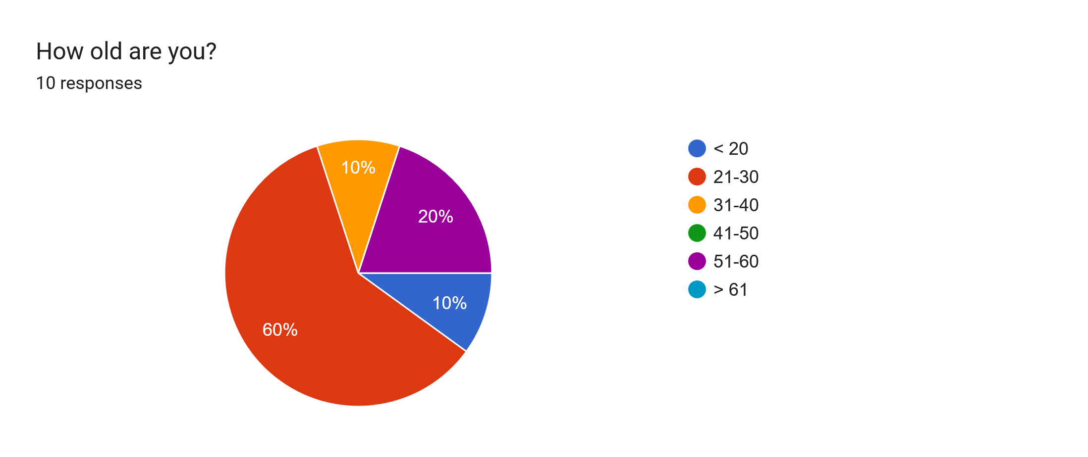
Using: (<20) = 15, (21-30) = 25, (31-40) = 35, (41-50) = 45, (51-60) = 55, (>61) = 65
- Mean : 31
- Median : 25
- Mode : 25 (60%)
- Std Dev (σ) : 12.806

Among the people we surveyed, the majority (60%) are in the age range of 21-30. If we also include the one person that is below 20 years old then 70% of our survey responders are in the young adult (below 30 years old) age range. So, we’ll be looking at our survey results from the perspective of young adult responders.

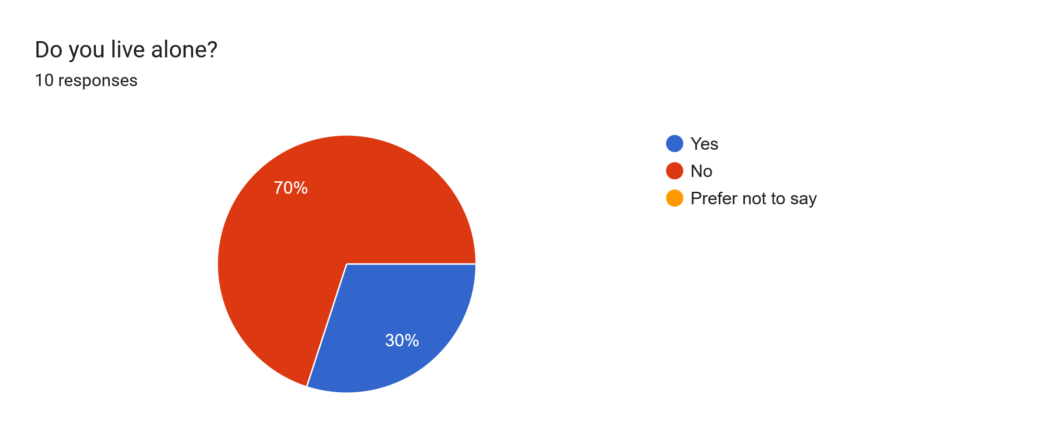
Using: Yes = 1, No = 0
- Mean : 0.3
- Median : 0
- Mode : 0 (70%)

The majority of our users doesn’t live alone, which might affect their cooking lifestyle.

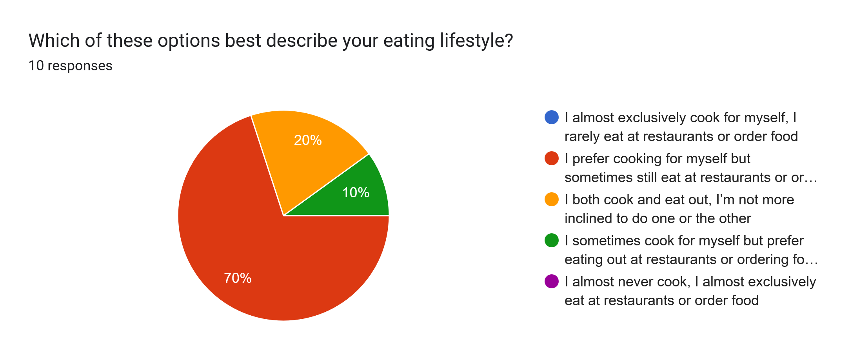
Using: Exclusively cook = 5, Mostly cook = 4, Equal = 3, Rarely Cook = 2, Never Cook = 1
- Mean : 3.6
- Median : 4
- Mode : 4 (70%)
- Std Dev (σ) : 0.663

The majority of our survey responders (70%) mostly cook over eating at restaurants. And 20% of them equally cook and eat outside. So the majority of our survey responders do cook on a regular basis.

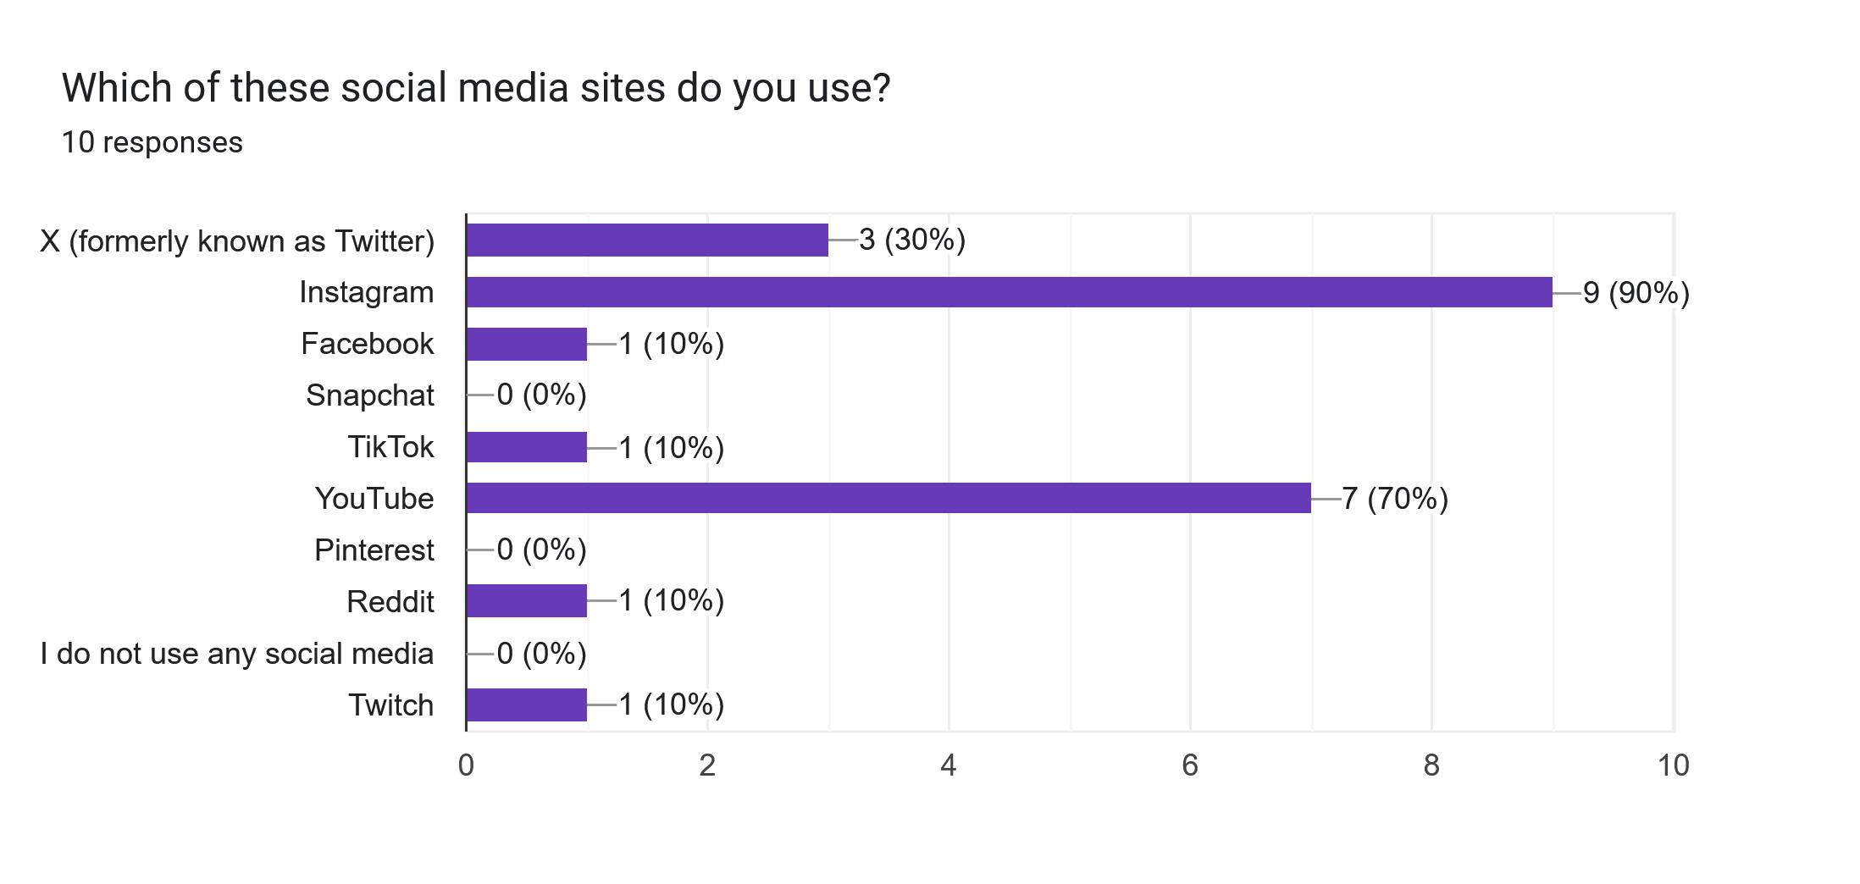
3 Highest Frequency:
- 1: Instagram (90%)
- 2: YouTube (70%)
- 3: X/Twitter (30%)

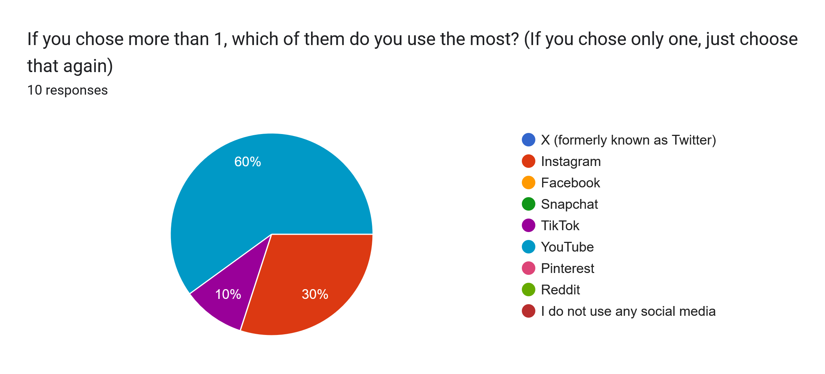
3 Highest Frequency:
- 1: YouTube (60%)
- 2: Instagram (30%)
- 3: TikTok (10%)

Most of our responders uses Instagram though the most used social media is YouTube.

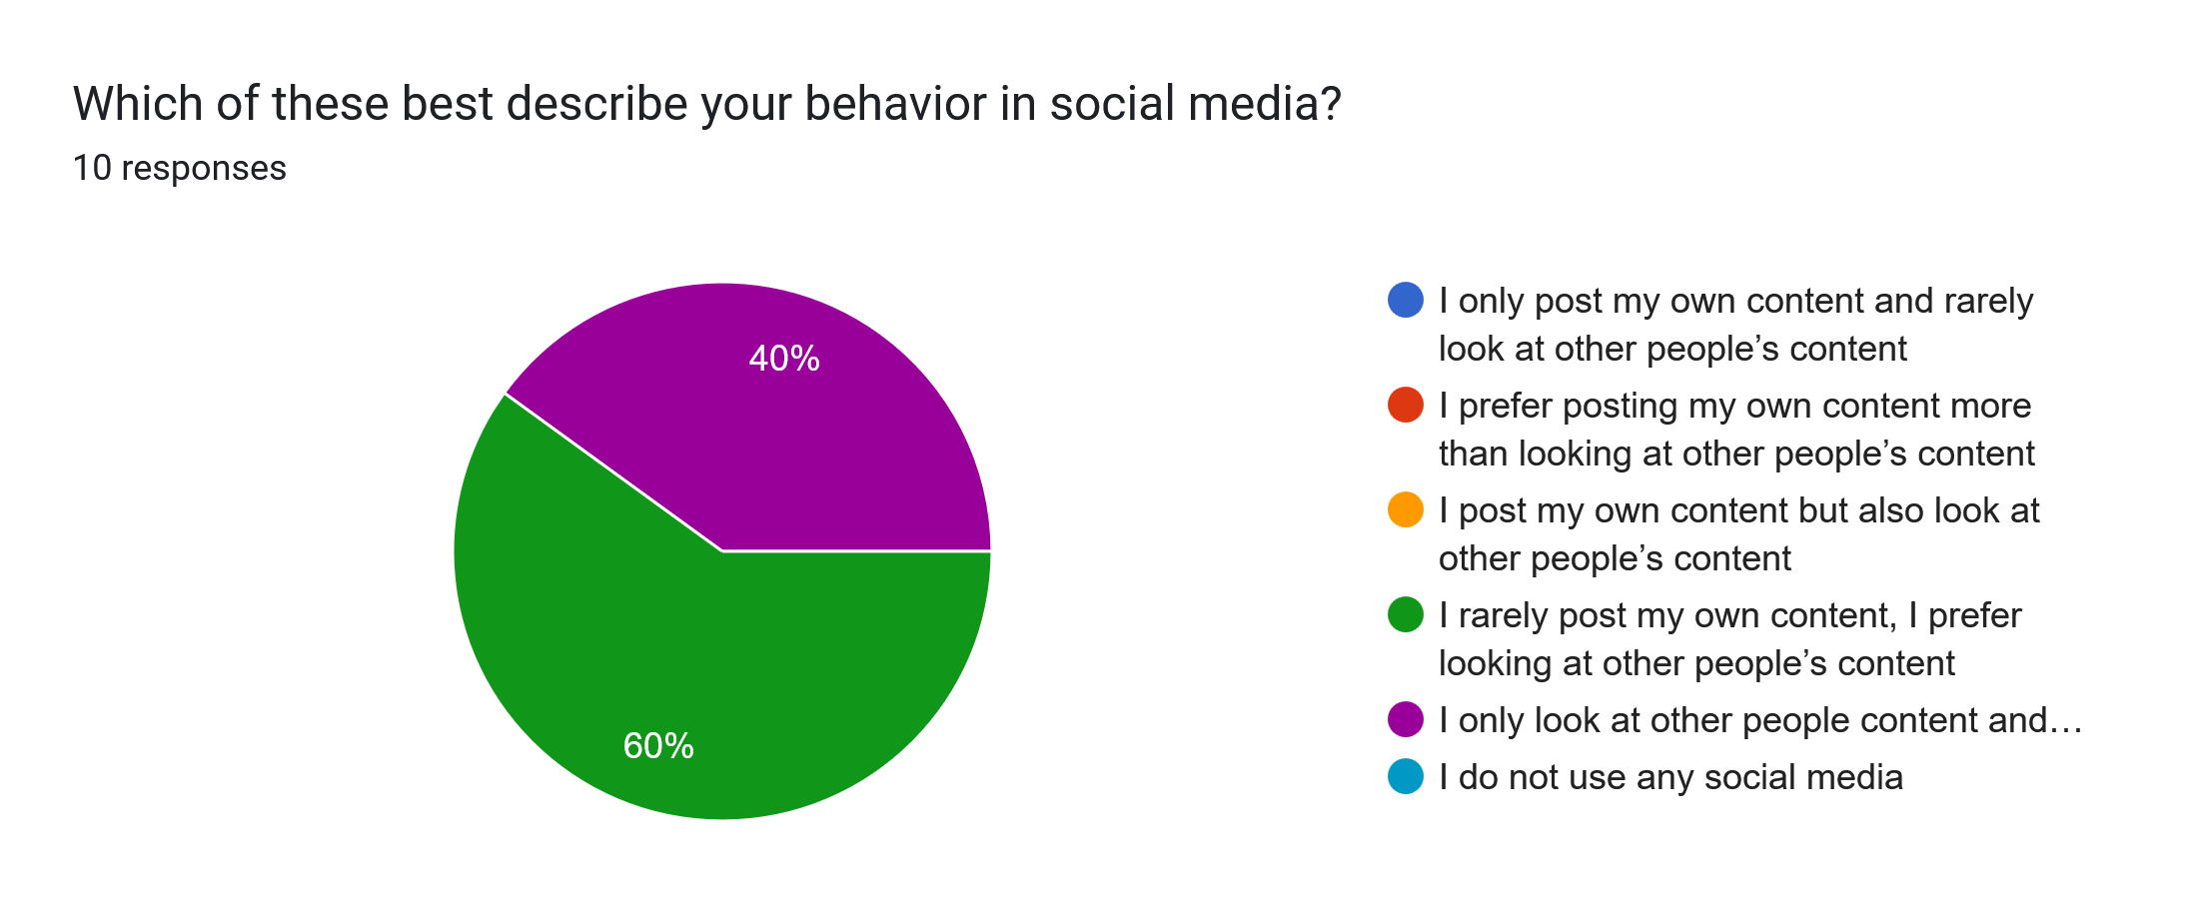
Using: Only Create Content = 5, Mostly Create Content = 4, Equal = 3, Rarely Create Content = 2, Never Create Content = 1, Don’t Use Social Media = 0
- Mean : 1.6
- Median : 2
- Mode : 2 (60%)
- Std Dev (σ) : 0.489

Most of our responders prefer looking at other people’s content instead of producing their own content in social media.

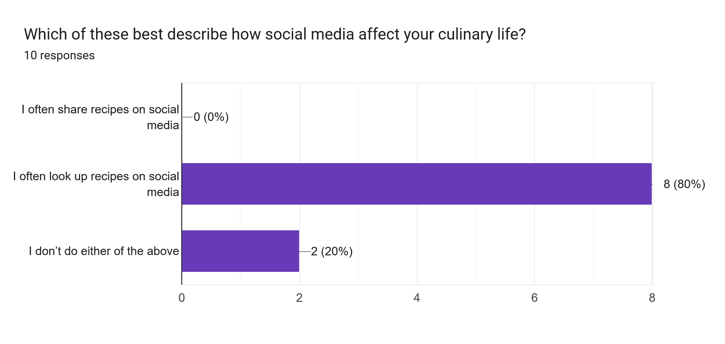
Most Common Answer: I often share recipes on social media (80%)

Most of our responders often looks up recipes on social media, though none of them share their own recipe which matches the social media behavior mentioned previously.

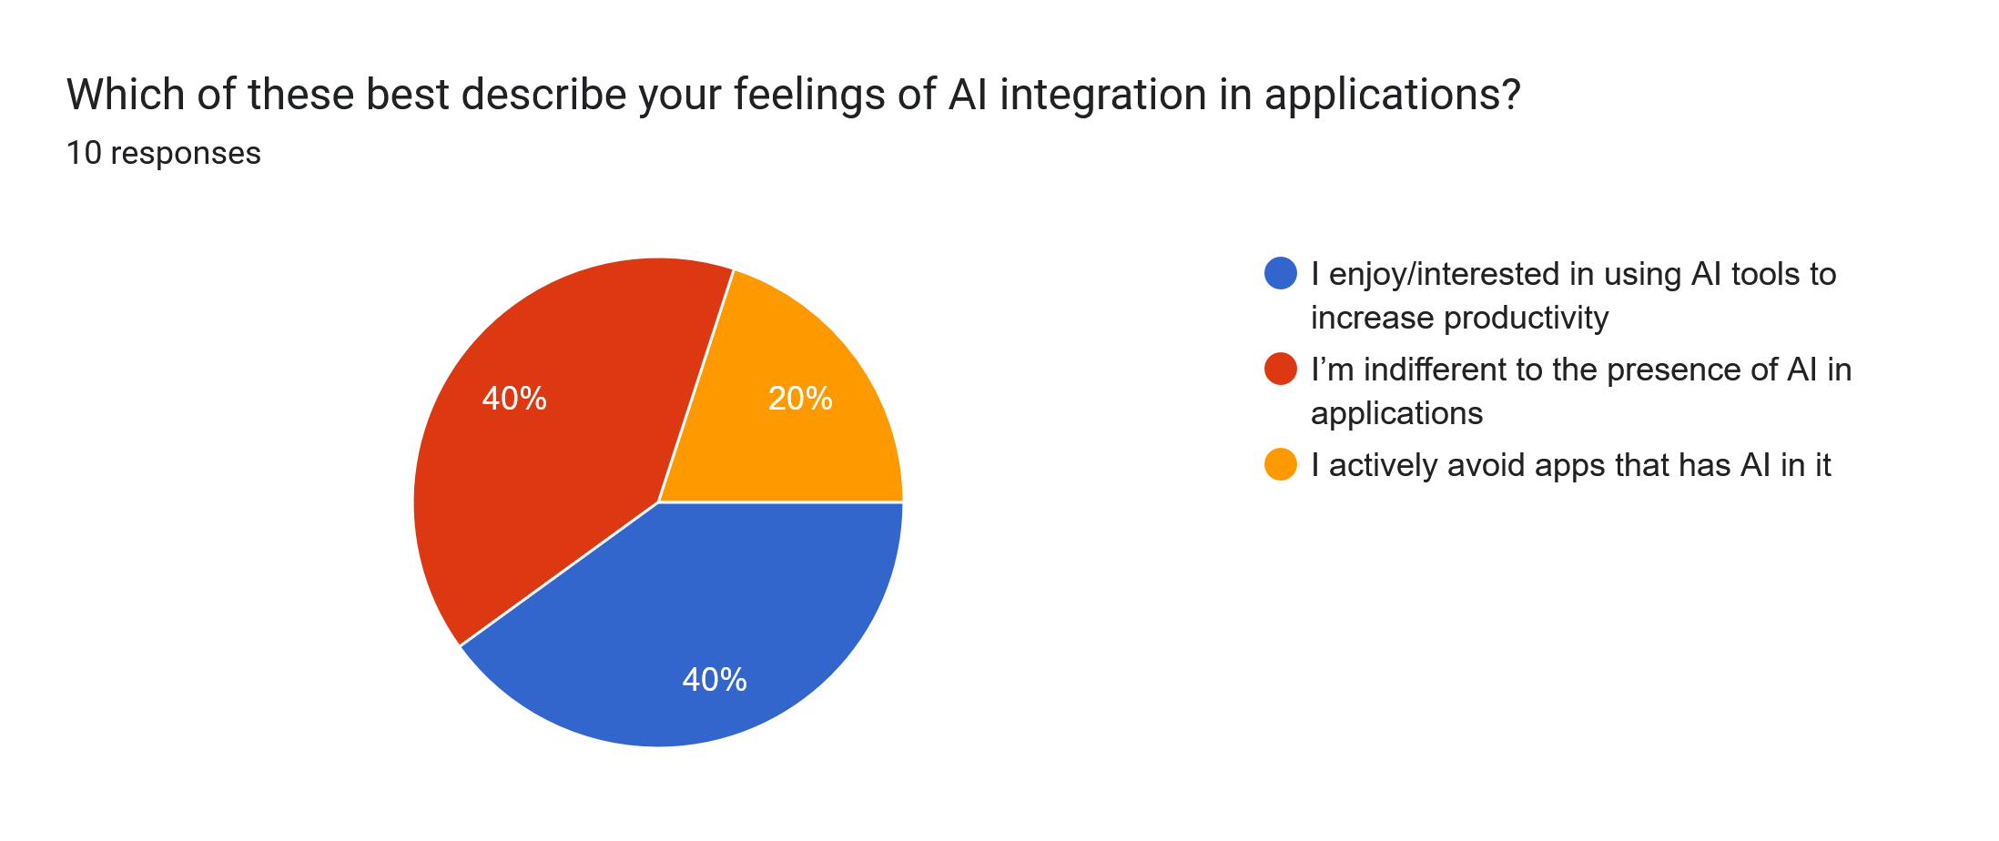
Using: Enjoy AI = 1, Indifferent to AI = 0, Avoid AI = -1
- Mean : 0.2
- Median : 0
- Mode : 0 and 1 (both 40%)
- Std Dev (σ) : 0.748

Most of our responders either enjoy AI or indifferent to them. Only a few of them avoids AI in apps.
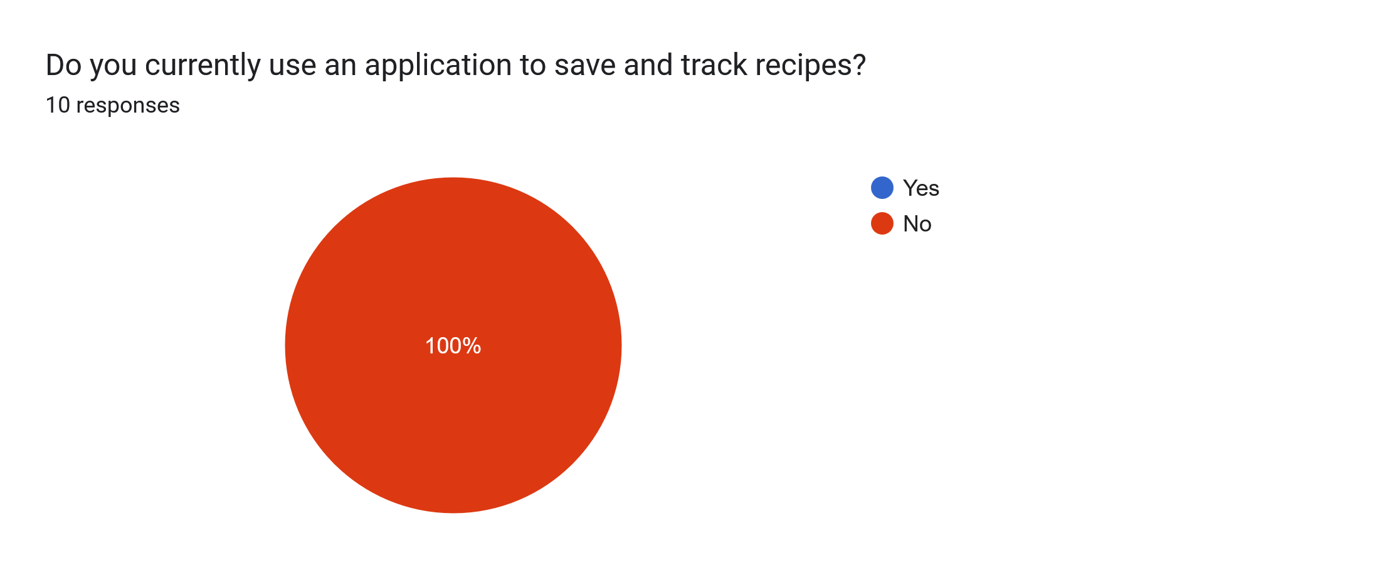
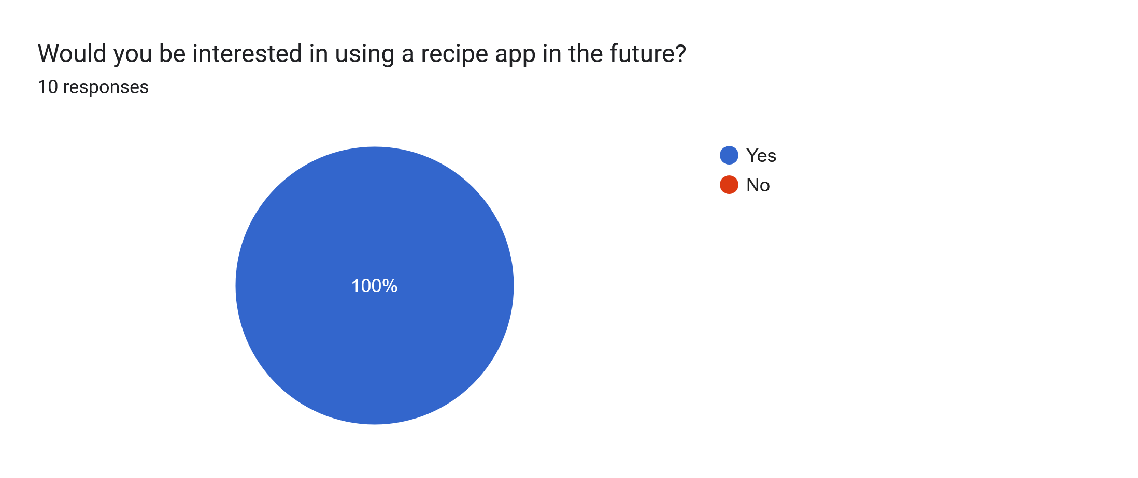
None of our responders are currently using a recipe app, which also means we didn’t get any survey results on the question of which recipe app is the most used. All of them are interested in using one in the future though.

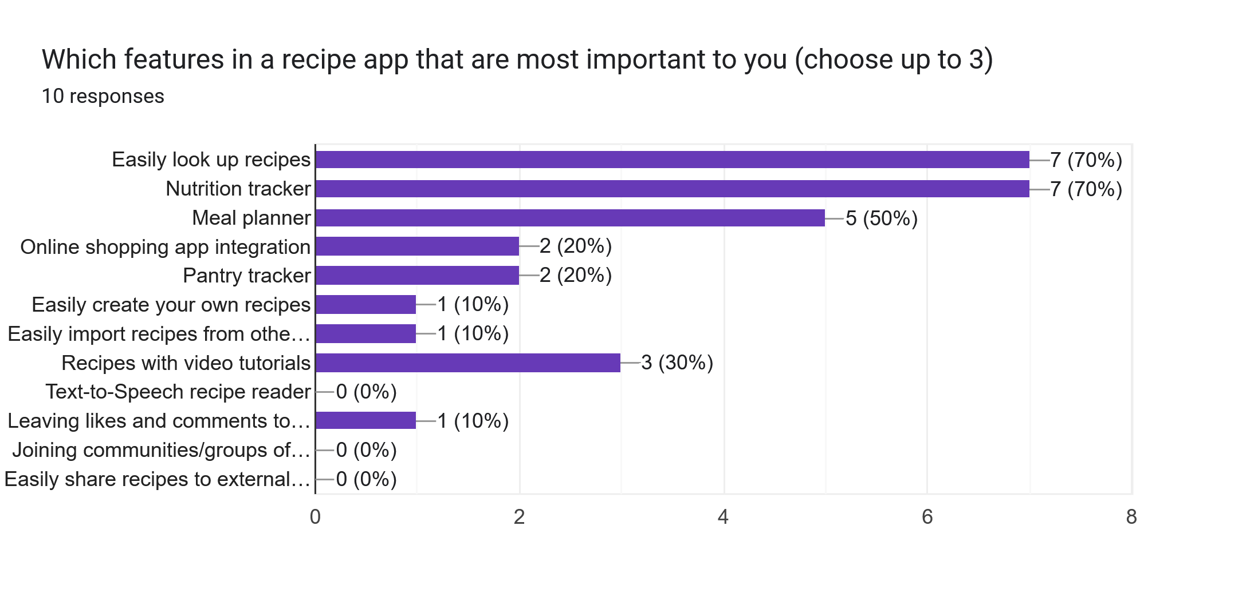
Highest Frequency:
- 1: Easily Look Up Recipes (70%)
- 2: Nutrition Tracker (70%)
- 3: Meal Planner (50%)
- 4: Recipes with Video Tutorials (30%)

The above bar chart shows which features are the most desired in a recipe app, which are recipe lookup, nutrition tracker, and meal planner. This matches the social media behaviour survey above where most of our respondents prefer consuming content instead of creating their own.

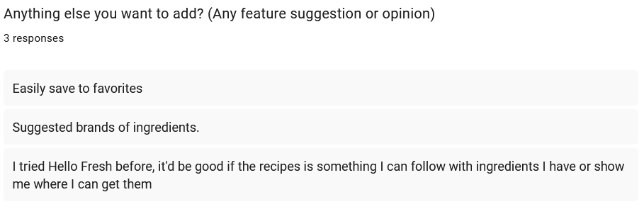
From our open ended questions, we got some more suggestions for features.

The first one, “easily save to favorites”, can be added to our app as it seems simple to add.

The second one, “suggested brands of ingredients”, might be more difficult to add as we’re not sure how would we rate each brand. Perhaps we can add a voting system where users can comment and vote on each brand? But that might cause a PR dispute against said brands so it’s something to consider.

The third one seems to want a ‘pantry tracker’ and ‘shopping cart’ feature which we’ll take into account for our app.

1e. Insights
- Overall most of the respondents fit the criteria of our target users, which are young adults who often cook for themselves. The fact that a lot of them doesn’t live alone might also suggest that they live in a decently sized household which suggests that they might have a decently well equipped kitchen so most of them are likely experienced cooks.
- The preferred social media of our respondents are YouTube and Instagram, so the content they seek seems to mainly be in the form of short to medium length videos. For the social media elements in our app we might condiser putting a bigger emphasis on video content (which incidentally will also be a novelty feature against the competing apps we reviewed in our market research)
- Our respondents are mainly content consumers, which is to be expected as content consumers are more prevalent than content creators. This means that at least at the very start of our app’s lifetime we won’t be seeing much content (recipes) created by users. Thus, our app would either need a pre-made list of recipes as a buffer, or integrate with a pre-existing social media to import content from there (or both).
- Most of our respondents are either indifferent or excited about AI so we shouldn’t shy about proudly showcasing any AI features in our app.
- None of our respondents are using a recipe app but are interested in using them in the future. Though we didn’t get any insight about which competitor is popular from this survey, this is a nice confirmation that there is still spot in the marketplace for our app.
- For the most desired features, one of them is “easily look up recipes”. In hindsight this probably shouldn’t be included as an option as this is the core feature of our app. But it does confirm once again that our users mainly desire to consume content instead of creating their own.
- Other popular requests are nutrition tracker, meal planner, and video tutorials. Video tutorials in particular reinforces that our users seek content in a video format.
- The open ended questions also yields some other requested requirements that we’ll add to our list of requirements, but perhaps as a “tertiary/bonus” requirement that we’ll implement if we have left over resources after the other requirements are met.

2. Requirements Generation

2a. Personas

Persona 1 : John
- Age 35 male
- Office worker
- Not normally an active person but recently started to work out
- Often eats fast food because he felt cooking is way to time consuming
- Recently found out that his cholesterol levels are high
- Want to start cooking for himself for health reasons

- John recently downloaded a recipe app to learn how to cook
- Because he usually eats at fast food restaurants, he’s not used to spending a lot of time to cook so he looks up recipes that’s easy and fast to prepare
- The recipe app gives him a list of recipes, and he sorts them based on nutrition values, prioritizing high protein food for his workouts
- He eventually settled on a chicken breast recipe that seems simple to prepare
- He wants to compliment the meal with vegetables, so he also asks the app to look up vegetable recipes that would complement this meal both flavour-wise and nutrition-wise
- He found a spinach recipe that he thinks he’ll like and adds that to his menu
- He then views the ingredient list and adds any ingredient he doesn’t own to a shopping cart, and then uses the app to order them online to be delivered
- He then prepares the meal using the app to guide him on how to cook it, the app uses text to speech to tell him the instructions and also providing a timer whenever needed
- Afterwards he uses the app to rate the meal based on how much he liked the flavours
- He repeats this process for several days, trying out a different meal each day and the app gradually learns the type of meals he likes based on his search specifications and rating
- Eventually he stops using the search function as the app has learnt his preferences and has started to recommend recipes that matches his preferences in the home page.
- From here onwards John mostly doom scrolls the home page and would often quickly find a recipe that he’d like

Persona 2 : Jean
- 55 years old female
- Housewife
- Lives with her husband, children have recently graduated high school and moved out
- Used to cook nutritious meals for her children, does it less often nowadays
- Often browses social media to learn new recipes
- Interested in finding friends of likeminded hobbies

- Jean opens the recipe app and checks out the home page for the trending recipes.
- She saves any ones she’s interested in to a “try later” list before going to the community tab where she had joined a group filled with people with similar food preferences
- She checks out the meals that other people had cooked and saves any recipe she thinks she’ll like
- The app then notifies her that a friend of her is planning to cook a difficult recipe and is looking for someone to help her cook
- She agrees and the app notifies her friend and sets up a chat between them
- After arranging the schedule, they agree to meet up on a later date. The app orders the ingredients and splits the bill between the two
- The app also suggests food that might compliment the meal, though they decided against it
- On the agreed day, they cooked the meal together. They also decided to record their cooking experience which the app automatically helps edit the video.
- They uploaded the video to their community group with the app marking the video as a group effort

Persona 3 : Jane
- 20 years old female
- College student, also works as a dishwasher part time
- Lives in a shared apartment with 2 roommates
- Mostly cooks for herself or sometimes cooks with her roommates

- Jane just came home from the supermarket, she has bought some ground beef and beansprouts.
- She wanted to cook something with it, so she takes out her recipe app and takes a picture of her groceries.
- The app then adds her groceries to her pantry which contains ingredients she previously added and currently owns.
- She then asks the app to looks up recipes that can be made with the ingredients in her pantry, specifying that she wants one with the ground beef as the main ingredient.
- She doesn’t find any recipe that she desires so she asks the app to also look up for recipes that are only missing 1-2 ingredients.
- She then sorts the recipes by the price, the app only takes account the price of the ingredients that she’s missing
- She finds a recipe she favours and the apps gave her an option to order the missing ingredients online
- She however refuses and asks the app to show all nearby shops that has the ingredients. The app then shows the list of nearby shops while also showing their prices and branding.
- She then goes and buys them and have the app added them to the pantry too
- Afterwards she decided to also cook for her roommates and asks the app to adjust the ingredient amount to fit a meal for three. The app adjusts the recipe accordingly.
- Jane cooks the meal and eats it with her roommates, of which one of them enjoys it so much that she asks for the recipe. Jane uses the app to share the recipe with her.

Persona 4 : Johnny
- 44 years old male
- Lives with his family of four
- Head chef of an Italian restaurant for 10 years, has cooking experience of 30 years
- Doesn’t use social media but recently his daughter has been checking out recipes from social media and recommended him to try sharing his recipes too

- Johnny downloads the app and registers an account. The app asks what he intends to achieve to with the app and Johnny specifies that he’s more interested in sharing his own recipes than looking at other’s recipes.
- The app then guides him to create his first recipe, he decides to try create a simple spaghetti recipe
- The app asks him for an ingredient list and he verbally says the ingredients which the app parses using the speech-to-text interpreter.
- The app then does the same for the instructions. However, some of his instructions were vague and the app asks for more details for the steps.
- The app asks Johnny to add tags to his recipe, and recommends some tags based on the title, ingredients, and instructions such as “Italian” and “simple”
- The app then suggests Johnny to record a video of him cooking the recipe which helps make the recipe looks more professional. Johnny then sets up the phone to record himself cooking said recipe.
- The app then automatically edits the video for Johnny, segmenting the video to match each step of the instruction, cutting off parts that it deems unimportant, and fast-forwards each step to make it concise.
- The app also notices that Johnny has added salt to the recipe in the video and notifies him that he forgot to add salt to the ingredient list. Johnny then asks the app to add it to the ingredient list.
- Johnny then views the recipe that he has created assisted with the app and after he was satisfied, he posts it.
- Afterwards the app suggests that Johnny complete his profile. As he intends to post recipes, the app recommends that Johnny should specify his cooking experience or any cooking-related jobs to help convince people to try his recipe, which he does.
- The recipe got some traction which made Johnny happy, he then started sharing more recipes.

2b. Requirements Generation

Individual Persona Analysis
John | Jean | Jane | Johnny
- Adult male  - Office worker  - Lazy  - Unhealthy food choices  - Not physically active  - Inexperienced at cooking  - Likely doesn’t have many kitchen utensils or utilities apart from the bare minimums  - Recently started to be aware of his health issues  - Recently started working out  - Want to improve his lifestyle and health  - Doesn’t challenge himself  - Open to change but does it slowly | - Older Female  - Stay-at-home Housewife  - Lonely  - Bored (children recently moved out, might suddenly feel like she has too much free time)  - Plenty of cooking experience in a household setting  - Sociable  - Looking for friends  - Loves sharing | - Young female  - College student  - Works a part time job  - Lives with 2 roommates  - Budget minded  - Picky eater  - Not Lazy  - Attention to detail  - Gets along with her roommates  - Generous (shares her food) | - Middle aged family man  - Head chef, 30 years of cooking experience  - Skilled  - Has a well-equipped kitchen  - Doesn’t use social media  - Interested in sharing cooking knowledge  - Meticulous  - Gives vague instructions (maybe isn’t used to viewing cooking from a non-chef perspective)  - Isn’t used to technology (reliant on the app to do the heavy work)  - Open to suggestions  - Not stubborn  - Enjoys positive feedback

Master List of Requirements
- Login/Registration
- Goals: do they want to look up recipes, or share recipes
- Personalization: App gradually learns user food preferences through history, recommend complimentary dishes to meals
- Home Screen: Display trending recipes, recipes that fits user preferences, doomscrolling
- Filtering / Sorting: Based on price, nutrition, tags (e.g. Italian), main ingredient, allergies, skill level requirement, necessary kitchen tools/utensils, look for dishes that compliment another dish
- Social Media Aspects: posts, communities, friend groups, cooking collaborations, recipe sharing, experience sharing (share cooking experience or food photos), perhaps connect experienced cooks with users who are interested in learning, sharing with external social media (and vice-versa: import content from external social media)
- Input: written, speech-to-text, image-to-text, app provides suggestions
- Nutrition Tracker: Keep track of food nutrition, image analysis of nutrition labels, allow keeping track of nutrition from external food (made without the app), alert users if nutrition goals aren’t met, track history of health metrics (e.g. weight, blood pressure, cholesterol level, blood sugar), suggest dietary improvement based on health and nutrition
- Pantry: keep track of food owned, keep track of quantity and expiration dates
- Shopping List: allow ordering ingredients in app (or integrate external shopping app), allow searching for nearby shops that has ingredients
- Video Editing: for recipes or for social media post, app assisted video editing
- Kitchen Assistant: Meal size adjustment (ingredient quantity dynamically adjusts), text-to-speech assistant (with speech-to-text input), timers that match recipe needs, audiovisual tutorials, recommend complimentary additions, integration with smart cooking devices, suggest replacement ingredients if missing or an ingredient need to be avoided e.g. because allergy
- Notifications: give suggestions when users creating a meal, notify users if someone liked their created content

3. Synthesis of Requirements Gathering and Generation
Aaa

4. AI Use Section
AI Tool Name | Version, Account Type | Feature Used | Value Addition | Appendix

5. Work Log

6. References
-

